Overview
This document is designed to provide grant applicants with instructions for use of the Foundant Grant Lifecycle Manager application. Remember while this document attempts to provide step-by-step instructions, we realize that not all user scenarios may be adequately covered. If you remain on a page with inactivity for longer than 90 minutes, you will be logged off for security reasons. The system will auto save as you move from question to the next, and will save every 100 characters in longer text responses. Auto save is noted by the border of the question highlighting in green

Registration Page
If you already have an account with this Foundant Grant Lifecycle Manager;
- Enter your Login, which is your e-mail address, in the Email Address field.
- Enter the Password that you chose when you set up your account.
- Press the “Log On” button to enter the Grant Lifecycle Manager.

If you have forgotten your password;
- You can click on the Forgot your Password link, enter your User ID, and the system will email your password to your e-mail account.
If you do not have an existing account;
- Click on Create New Account to register.
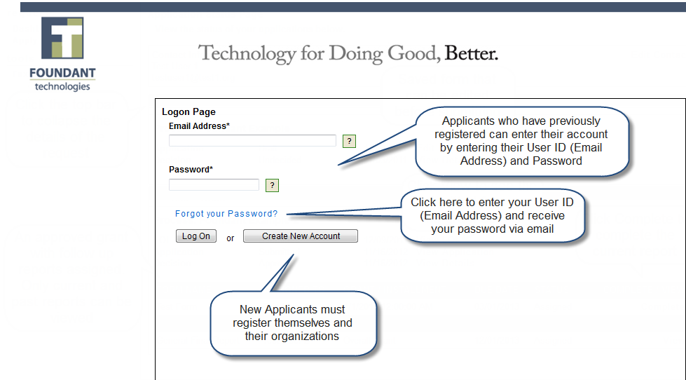

To register an account
- Click on Create New Account
- Enter your organization information
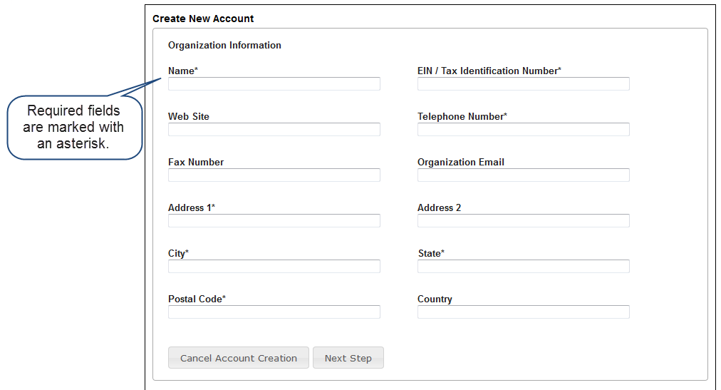
- Click on the Next Step button
- Enter your contact information
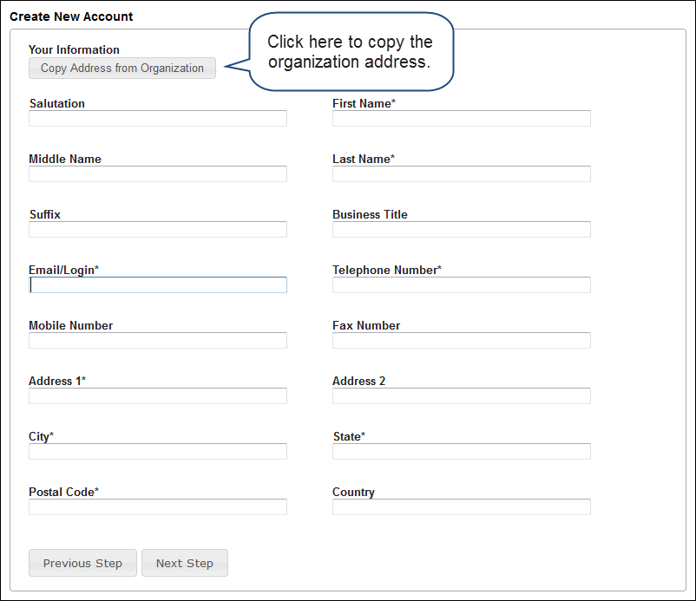
- Click on the Next Step button
- Indicate whether or not you are the organization’s executive
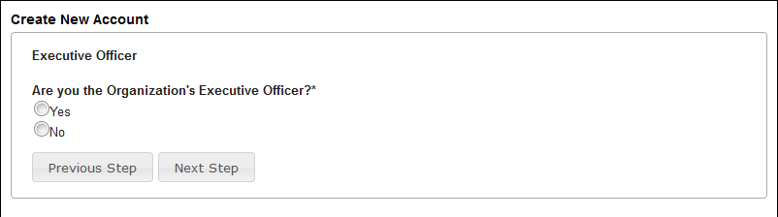
- Click on the Next Step button
- Enter the organization executive information
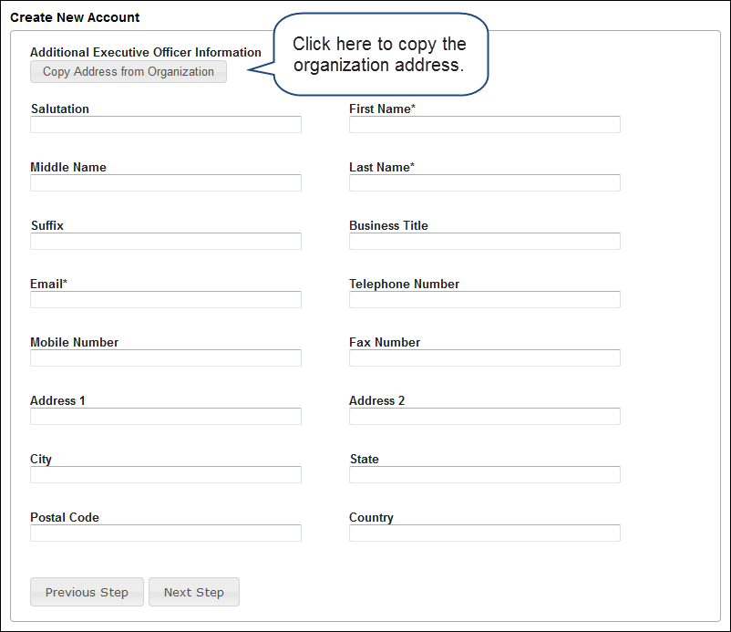
- Click on the Next Step button
- Enter your password
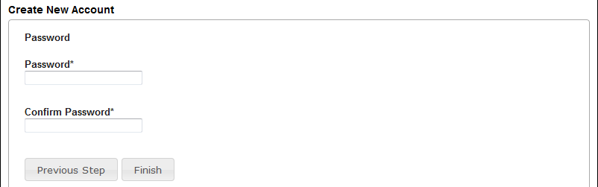
- Click on the Finish button
- Confirm that you received your registration email from the system. It is important to make sure you can receive emails, as this will be a method of communication from the organization.
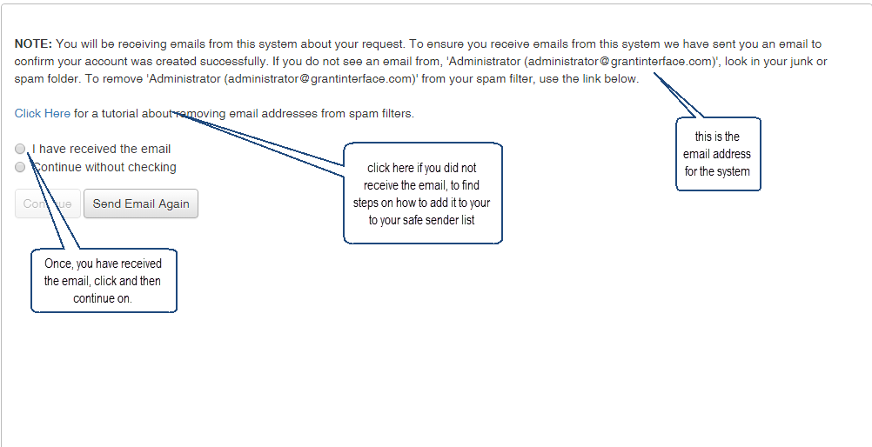

Applicant Status Page
After you have registered your account you will be directed to the Application Page.
- Apply – This allows you to review the available grants and apply.
- Dashboard – This is your homepage where you can check on the status of your grants. This page will display the form you just filled out, what its status is, and what the next form will be.
- Fax to File – Instead of scanning a document you can fax it to your computer. Using Fax to File helps shrink documents to a smaller file size.
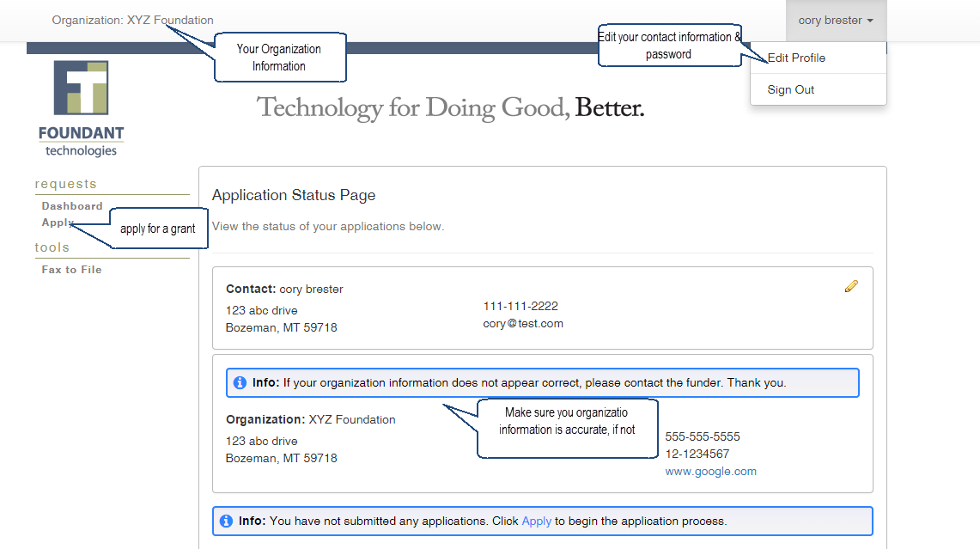

Choosing a Grant Program
After clicking on the Apply link you will have the ability to choose a grant program to apply for. Each grant program will have a brief description of the grant or who qualifies for the grant. Read these descriptions thoroughly before applying.
- Read through the grant program description to decide if you qualify to apply for the grant.
  - If the foundation has sent you an access code enter it in the Access Code box In the upper right corner and click “Enter Code.” This will allow only the private grant program to appear.
- After the grant program appears, click it to start filling out the first form.
  - Grant Programs have the ability for multiple forms. Some grant programs can have the applicant submit 3 forms to the foundation before a decision is made. Each form will be filled out and submitted to the foundation. After it is deemed complete, the foundation will approve you to move on to the next form.

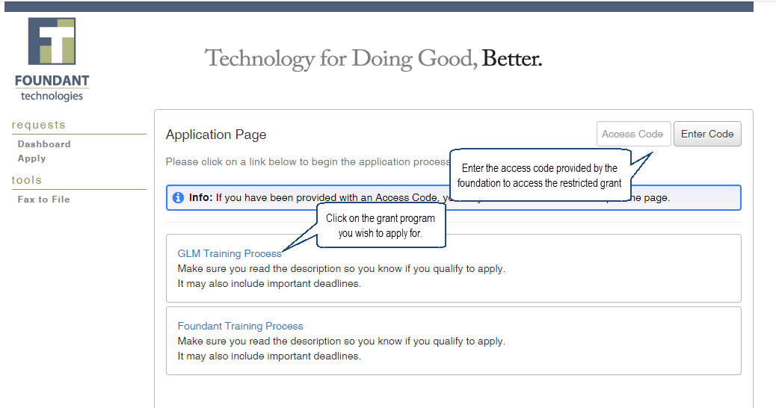

Filling out the First Form
After agreeing to the applicant instructions you will be sent to the first form in the grant program. Enter all the applicable information then Save as Draft or Submit the form to the foundation.
- Start filling out the questions on the form, paying close attention to the instructions and limitations on each question.
  - Certain types of questions have limitations set by the foundations. Text questions will have a character limit which only allows you to type or paste a certain amount of text in each question. Another limit will be on the file upload questions. This limit will be in Mega Bytes (MB). The size of file you are uploading must be under the amount of MB’s allowed on the question.
- Applicants can save as draft and come back to the form after any given time to complete it. The foundation will not check for completeness until the form is submitted.
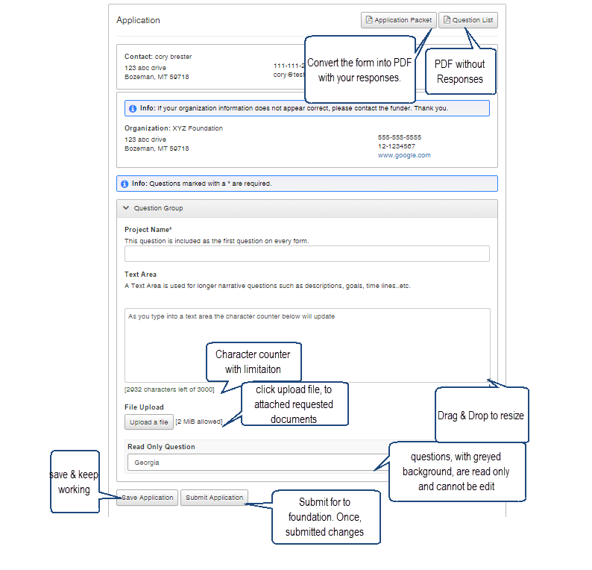
  - After the application is submitted there will be a confirmation page stating that the form has been submitted. You can always refer to your Application Status Page to see what stage the application is in, if in doubt.

Accessing Forms After Save and Submit
The Application Status Page is where you can check on the status of your applications and access for historical record keeping. The Application Status Page is your homepage. You will be automatically directed there when you login.
- If you’ve submitted the form then you can only view the grant request and print it.
- If you saved the form then you can Edit the saved form from the Application Status Page.
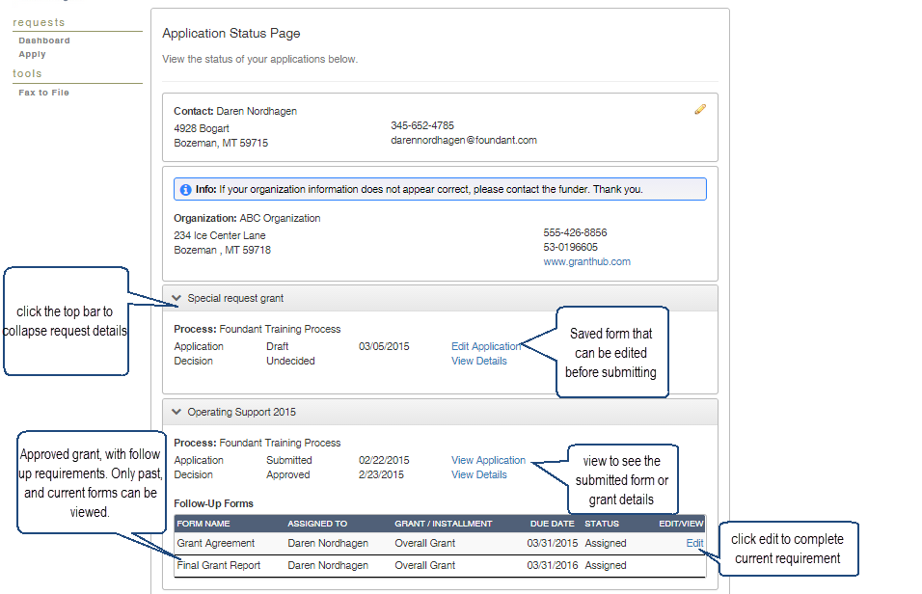

Viewing Decision Details
The Decision Details Page is where you can view the details of your grant and scheduled payments.
All organization may not have this viewable to applicants
- If the request is Undecided there will be no Payment Summary.
- If the request is Denied the Grant Amount will be $0.00 and the Grant Type will be Denied.
- If the Grant was approved you can click View Details to see Grant Amount, Grant Type (One Time, Installment or Matching) & Payment Schedule.
