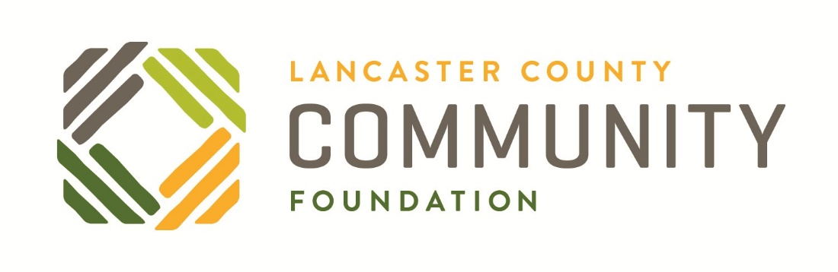
Community Plans and Initiatives
We encourage community benefit organizations to ensure their work is connected to existing community-level plans and initiatives. This list is a sampling of what we consider to be very important plans and initiatives in our community and is not meant to be comprehensive.

Building on Strength – Economic Development Strategic Plan for the City of Lancaster, PA – from Lancaster City Alliance
http://www.lancastercityalliance.org/building-on-strength/

Four Bold Goals – from United Way’s Collective Impact strategy
https://www.uwlanc.org/ourimpact

One Good Job – from Coalition to Combat Poverty
http://combatpovertylancaster.org/draft-plan/

Places2040: A Plan for Lancaster County, PA – from Lancaster County Planning Commission
https://www.places2040.com/

Prosperity Indicators – from Lancaster Chamber
http://www.lancasterchamber.com/article.aspx?page=prosperity-indicators

