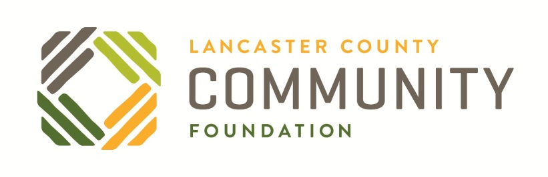
2022 Partnership Program
Information Sheet
PROGRAM PURPOSE: The Partnership Program supports the intentional and formal steps of bringing together multiple community benefit organizations or a community benefit organization with a for-profit organization through a merger, the legal binding of two or more organizations with overlapping or complementary missions, audiences or services into one organization to increase organizational efficiency and mission-related outcomes. To be eligible to apply, organizations must submit a formal declaration of intent to merge, signed by boards of directors chairs.

GRANT RANGE: Grant requests of up to $20,000 will be considered. The Community Foundation may consider offering partial funding of any given request.
ELIGIBLE PROGRAM COSTS: Legal fees, marketing/branding, organizational development planning, consultant or facilitator fees, and meeting expenses. Please consult with staff if you have other ideas for spending the funds.
ELIGIBILITY: Applications must come from current 501(c)(3) community benefit organizations that are registered with or exempt from the PA Bureau of Charitable Organizations and submitted a current 990. Community Foundation staff will verify these requirements utilizing Guidestar and other online resources. Organizations will also be required to submit:
- Audited or reviewed (not compiled, not a 990) financial statement prepared by an independent CPA firm within 12 months
- A current board of directors roster
Organizations (or the surviving organization) must benefit residents of Lancaster County, PA. The Community Foundation will accept only one application per project concept. Please refer to the “2022 Program & Grant Opportunities” guide for further eligibility details.
FUNDING PERIOD: Typically grants last for one year, but we would consider a longer grant for special circumstances.
AWARD NOTIFICATION: By phone or email (yes or no). Decisions are typically reached within 4-6 weeks of application submission.
APPLICATION PROCESS: Applicants must have a conversation with Dave Koser at 397-1629 ext. 112 prior to submitting an application. If your organization is eligible, you will receive an access code. Go to www.LancFound.org/grants, login or register as a Grant Applicant and enter the access code to begin the application process.

STAFF FEEDBACK ON APPLICATION DRAFTS: Community Foundation staff will review and comment on application drafts. Application drafts should be SUBMITTED through the grant portal. Drafts that are saved, but not submitted, will NOT be considered for preliminary feedback.

APPLICATION DEADLINE: For this program, applications will be accepted at any time until December 1, 2022, or until available funding is exhausted.

APPLICATION QUESTIONS:
- What are your organizations’ non-discrimination policies? (File upload or 10,000 characters text)
- Who are the partners and what are their missions? (1,500 characters)
- What are your organizational aspirations and current challenges regarding racial equity and inclusion, and/or social justice? Does this work relate to your project? If so, please describe. (2,500 characters)
- What are the goals of the partnership? (1,500 characters)
- Where are you currently at in the process? (1,500 characters)
- What are the implementation steps and timeline to put the partnership in place? (2,000 characters)
- How will the grant dollars by utilized? (1,500 characters)
- Any additional information or comments? (750 characters)
Applicants will be required to attach a board of directors roster for the applying organization, an audited or reviewed financial statement for the applying organization, and a memorandum of understanding (MOU) or other document that demonstrates the organizations’ intent to merge.
GRANT CRITERIA:
- Goals and Objectives
Are the goals and objectives clearly outlined? Does the partnership bring operational efficiencies, increase access of services and/or increase the impact in the community?
- Equity and Inclusion
How are the organizations considering the role they play to increase equity and inclusion in our community, and does merger help achieve those goals?
- Implementation Plan
Does the application outline a clear implementation plan, timeline and utilization of grant funds?

- Trust and Buy-in
Does the application demonstrate that the Executive Directors, Boards of Directors and staff from all organizations involved have worked to develop trust and buy-in with the merger process?

APPLICATION REVIEW PROCESS:
1. Conversation of Intent - Contact Community Foundation staff to set up a meeting to discuss your interest in submitting an application. If staff determines it is a good fit for the program, they will give the organization an access code to apply online.
2. Application Submission – Partners submit an online application. In addition to the documentation listed under “Eligibility” section, we will require a Memorandum of Understanding or other documentation demonstrating organizational intent to partner, signed by board chairs representing the organizations.
3. Application Review – Applications are reviewed to determine eligibility, fit for the fund, alignment with criteria stated above, receipt of required documents and due diligence. Staff may request additional information or adaptations to the application.

PARTNER REPORTING
- Completion Report – typically one month after grant completion
- Invoices for expenses of $500 and over
- Reports are to be completed using the grant portal (goo.gl/89hMXT).

