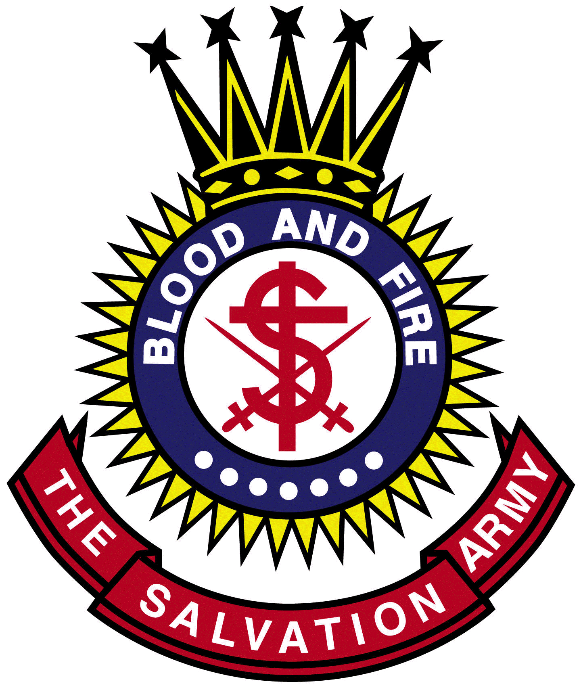

BRIAN PEDDLE WILLIAM A. BAMFORD
General Territorial Commander

The Salvation Army
founded in 1865 by william and catherine booth
Majors Thomas & Susan, Commanding Officers
131 S. QUEEN STREET, LANCASTER, PA 17603
TELEPHONE (717) 397-7565, FAX (717) 397-6255

OLGA RUTH STRATTON & THOMAS E WOLF SCHOLARSHIP 2023

The Salvation Army Olga Ruth Stratton and Thomas E. Wolf Scholarship funds was established to make it possible for students of low to moderate income households to attend higher education institutions to continue their academic study or to learn a trade specialty.

ELIGIBILITY:
- Applicants must be residents of Pennsylvania, residing in Lancaster County.

- Applicants must demonstrate a need for higher education financial assistance.

- Applicants must be candidates for graduation from their High Schools (or for receiving a GED certificate) in the current year.

- Applicants must have a grade point average of 2.0 or higher.

- All applicants are required to:
  - Complete and submit the ORS/TEW Scholarship Application Forms (QR code found on bottom of page)
  - Submit High School Transcript. If transcript does not include 12th grade, submit copies of 12 grade report cards.
  - Submit at least two (2) recommendation letters from people familiar with the applicant (i.e. teacher, principal, clergy, employer, etc.). One must be academic in nature and one must be community service related.
  - Submit a one (1) page essay (450-500 words) stating his/her college and career goals and involvement in community service activities & initiatives including any leadership roles held.
  - If selected to do so, attend scheduled interview with Committee (see letter I below).

- All required application materials must be received by the end of the day on Monday, March 20, 2023.

- Scholarship winners must be accepted by a degree granting college or university, or by an accredited institution of higher learning or training such as community college, trade school, nursing school, etc. in order to receive the scholarship.

- Scholarship winners must be entering their first year of higher education in the current year.

- Upon review of completed applications, the ORS/TEW Scholarship Committee will select students to be interviewed. Interview date will be Thursday, April 6th. Interviews will be available in person. Applicants to be scheduled for an interview will be contacted by phone and/or e-mail and must follow up with The Salvation Army staff to confirm their interview appointment time.

- Individual scholarships with a minimum award of $1,000 (depending on need, circumstances, and available funds) will be made to those selected by the interview committee.

- Scholarship certificates will be presented at the The Salvation Army Scholarship Dinner at the Eden Resort on Thursday, April 27, 2023 at 6:30 pm.

- Scholarships will be awarded regardless of the applicant’s race, religion, national origin, sex, age, or physical handicap.

Link: https://forms.office.com/r/BCc6rpmqC4

